Lab 08 Test Plan

Test | Test Values | Expected Result | Actual Results | Test Results
Program loads all files successfully | Run the program | Shows the menu | Shows the menu  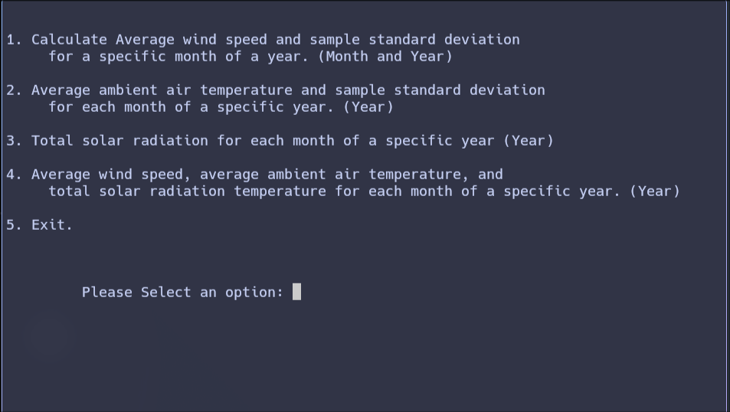 | Passed
Test option 1: print out the Average wind speed for a specific month and year | Option: 1  Month: January  Year: 2016 | Average wind speed: 6.3km/h  Sample stdev: 2.9 | Average wind speed: 6.3km/h  Sample stdev: 2.9  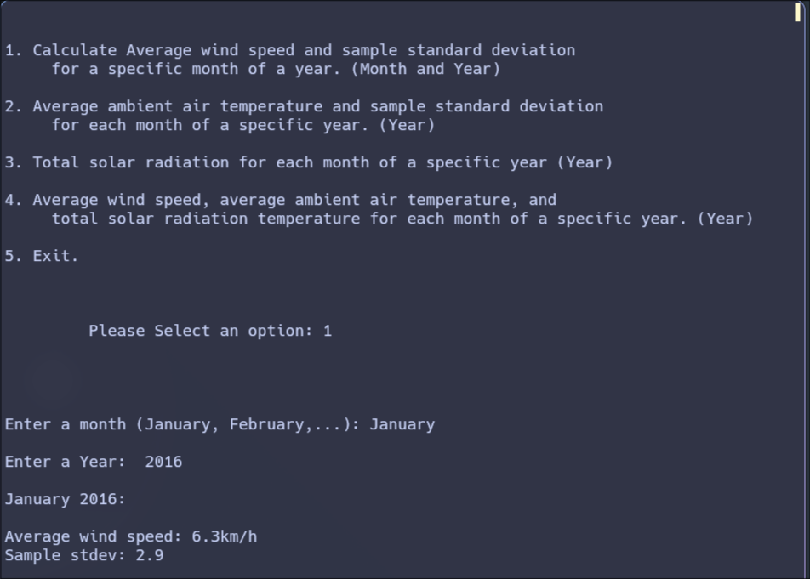 | Passed
Test option 2:  Print out the Average wind temperature for a specific year | Option:2  Year: 2011 | Produce the sensor values for all the months in the year 2011 | 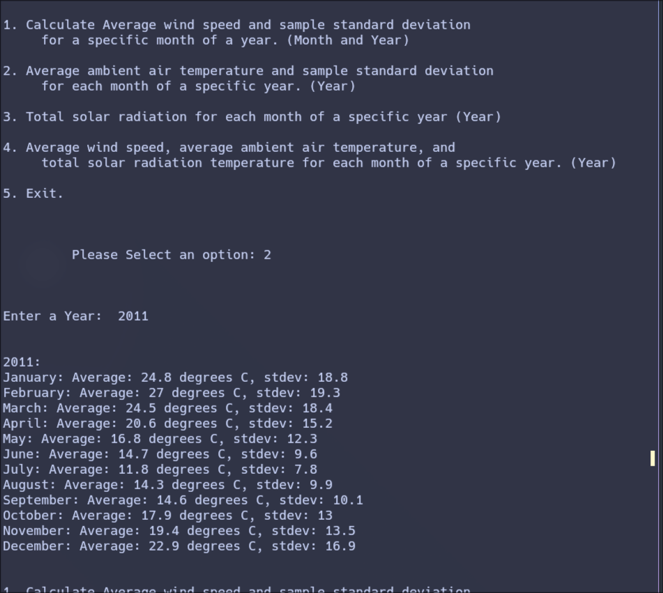 | Passed
Test option 3: Print out the Average solar radiation for a specific year | Option:3  Year: 2015 | Produce the sensor values for all the months in the year 2015 | 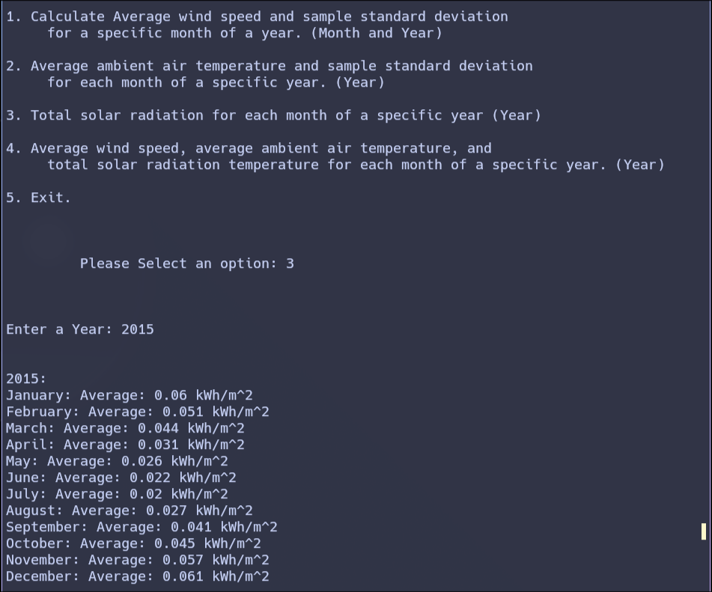 | Passed
Test option 4: Insert all the sensor values of a specific year into a csv file | Option : 4  Year:2014 | Insert all the sensor values for all the months in the year 2014 into a csv file called WindSolarTemp.csv | 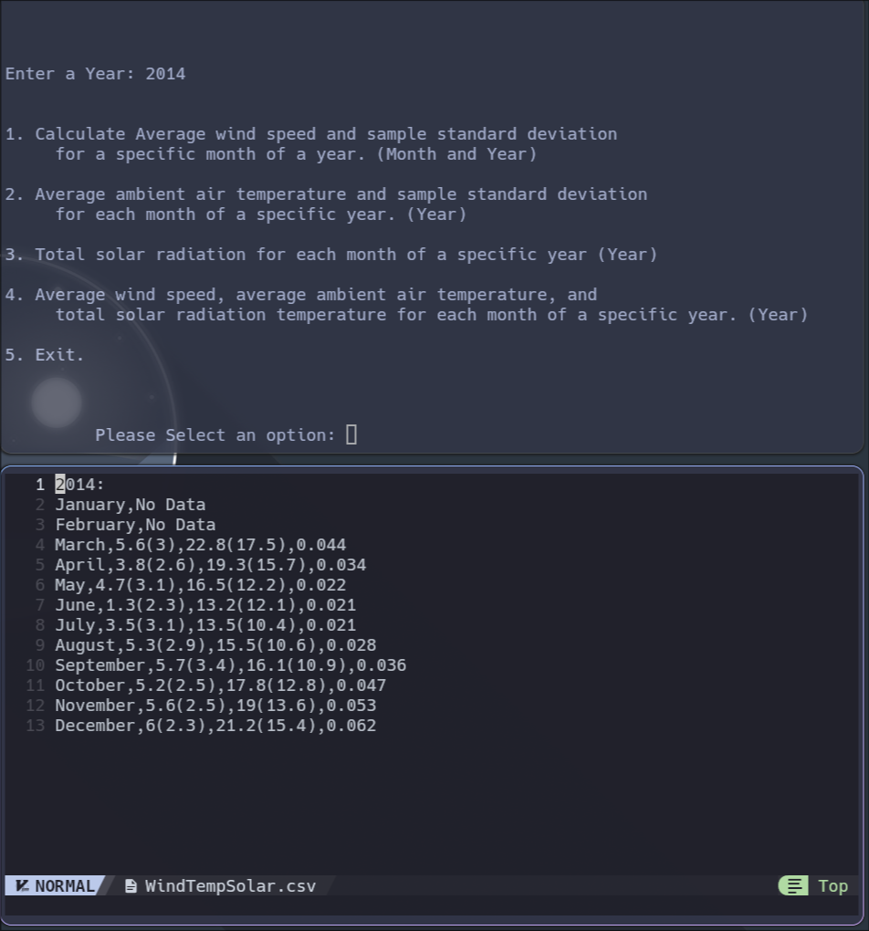 | Passed
Tesst option 5: Exit the program | Option: 5 | Return 0 | 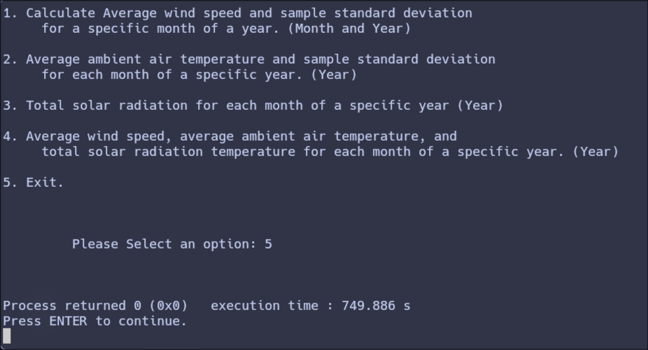 | Passed

